Assignment 9

**Question 1**: Create an abstract class DataHolder containing the following data members:

* One finite sized array
* Two data members front and rear
* Insert and delete method

Now create two concrete classes Stack and Queue using DataHolder class and also implement required functions.

**Code:**

import java.util.Scanner;

abstract class DataHolder {

final int MAX = 100;

int arr[] = new int[MAX];

int front = -1, rear = -1;

abstract void insert(int newElm);

abstract void del();

abstract void display();

}

class Stack extends DataHolder {

void insert(int newElm) {

if (rear >= MAX - 1) {

System.out.println("Stack Overflow!");

} else {

arr[++rear] = newElm;

System.out.println("\tInserted");

}

}

void del() {

if (rear < 0) {

System.out.println("Stack Underflow!");

} else {

rear--;

System.out.println("\tDeleted");

}

}

void display() {

if (rear == -1)

System.out.println("Nothing to display!");

else {

System.out.print("The Element(s) are: ");

for (int i = 0; i <= rear; i++)

System.out.print(arr[i] + " ");

System.out.println();

}

}

}

class Queue extends DataHolder {

void insert(int newElm) {

if (rear == -1) {

front++;

arr[++rear] = newElm;

System.out.println("\tInserted");

} else if (rear < MAX - 1) {

arr[++rear] = newElm;

System.out.println("\tInserted");

} else {

System.out.println("No more space!");

}

}

void del() {

if (rear == -1) {

System.out.println("Nothing to delete!");

} else {

front++;

if (front > rear) {

rear = front = -1;

}

System.out.println("\tDeleted");

}

}

void display() {

if (rear == -1)

System.out.println("Nothing to display!");

else {

System.out.print("The Element(s) are: ");

for (int i = front; i <= rear; i++)

System.out.print(arr[i] + " ");

System.out.println();

}

}

}

class Main {

public static void main(String args[]) {

Scanner sc = new Scanner(System.in);

System.out.print("Enter 1-> for Stack 2-> for Queue: ");

int ch = sc.nextInt();

if (ch == 1) {

Stack st = new Stack();

int flag;

System.out.println("Stack created.\nEnter\n1:Insert\n2:Delete\n3:Display\n4:Exit");

do {

System.out.print("Enter the command: ");

flag = sc.nextInt();

switch (flag) {

case 1:

System.out.print("Enter the element: ");

st.insert(sc.nextInt());

break;

case 2:

st.del();

break;

case 3:

st.display();

break;

case 4:

break;

default:

System.out.println("invalid input!");

}

} while (flag != 4);

System.out.println("Bye!");

} else if (ch == 2) {

Queue st = new Queue();

int flag;

System.out.println("Queue created.\nEnter\n1:Insert\n2:Delete\n 3:Display\n 4:Exit");

do {

System.out.print("Enter the command: ");

flag = sc.nextInt();

switch (flag) {

case 1:

System.out.print("Enter the element: ");

st.insert(sc.nextInt());

break;

case 2:

st.del();

break;

case 3:

st.display();

break;

case 4:

break;

default:

System.out.println("invalid input!");

}

} while (flag != 4);

System.out.println("Bye!");

}

}

}

**Output:**

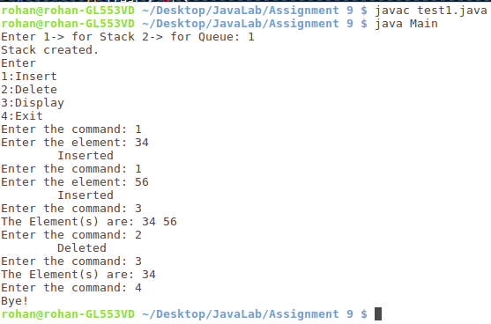

**Question 2:** Create a dynamic stack using Linked List

**Code:**

import java.util.Scanner;

class Stack {

Node top;

Stack() {

Node top = null;

}

void push(int elm) {

top = new Node(elm, top);

System.out.println("\tPushed");

}

void pop() {

if (top == null)

System.out.println("Nothing to delete!");

else {

top = top.next;

System.out.println("\tPopped");

}

}

void display() {

if (top == null)

System.out.println("Nothing to display!");

else {

Node temp = top;

System.out.print("The elements in the Stack: ");

while (temp != null) {

System.out.print(temp.elm + " ");

temp = temp.next;

}

System.out.println();

}

}

}

class Node {

int elm;

Node next;

Node(int newElm) {

elm = newElm;

next = null;

}

Node(int newElm, Node nxt) {

elm = newElm;

next = nxt;

}

}

class Main {

public static void main(String args[]) {

Scanner sc = new Scanner(System.in);

Stack st = new Stack();

int flag;

System.out.println("Enter\n 1:Push\n 2:Pop\n 3:Display\n 4:Exit");

do {

System.out.print("Enter the command: ");

flag = sc.nextInt();

switch (flag) {

case 1:

System.out.print("Enter the element: ");

st.push(sc.nextInt());

break;

case 2:

st.pop();

break;

case 3:

st.display();

break;

case 4:

break;

default:

System.out.println("Invalid input!");

}

} while (flag != 4);

System.out.println("Bye!");

}

}

**Output:**

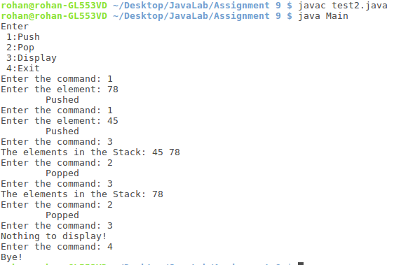

**Question 3:** Write a JAVA program to sort N values using Stack data structure

**Code:**

import java.util.Scanner;

class Stack {

Node top;

Stack() {

top = null;

}

Stack(Stack copy) {

if (copy.top == null)

top = null;

else {

top = new Node(copy.top.elm);

Node tempc = copy.top, temp = top;

while (tempc.next != null) {

tempc = tempc.next;

temp.next = new Node(tempc.elm);

temp = temp.next;

}

}

}

void push(int elm) {

top = new Node(elm, top);

}

void pop() {

if (top == null)

return;

else

top = top.next;

}

void display() {

if (top == null)

System.out.println("Nothing to display!");

else {

Node temp = top;

System.out.print("The elements in the Stack: ");

while (temp != null) {

System.out.print(temp.elm + " ");

temp = temp.next;

}

System.out.println();

}

}

void sort() {

if (top == null) {

System.out.println("Nothing to sort!");

return;

}

Stack temp = new Stack(), copy = new Stack(this);

top = new Node(copy.top.elm);

Node temp_n = copy.top;

while (temp_n.next != null) {

temp_n = temp_n.next;

while (top.elm < temp_n.elm) {

temp.push(top.elm);

this.pop();

if (top == null)

break;

}

this.push(temp_n.elm);

while (temp.top != null) {

this.push(temp.top.elm);

temp.pop();

}

}

}

}

class Node {

int elm;

Node next;

Node(int newElm) {

elm = newElm;

next = null;

}

Node(int newElm, Node nxt) {

elm = newElm;

next = nxt;

}

}

class Main {

public static void main(String args[]) {

Scanner sc = new Scanner(System.in);

Stack st = new Stack();

System.out.print("Enter the size of stack: ");

int n = sc.nextInt();

System.out.print("Enter the elements in the stack: ");

for (int i = 0; i < n; i++) {

st.push(sc.nextInt());

}

System.out.print("\nBefore sorting:\n\t");

st.display();

st.sort();

System.out.print("\nAfter sorting:\n\t");

st.display();

sc.close();

}

}

**Output:**

